1970
Account for the observation that silver dissolves in 1 molar hydroiodic acid despite the fact that the standard electrode potential for the change, Ag → Ag⁺ + e- is –0.80 volt.
Answer:
The standard potential is based upon [Ag⁺] = 1.0 M. But because AgI is insoluble (very small K_{SP}) the concentration of Ag⁺ never reaches 1.0 M. Therefore, the equilibrium is shifted in favor of the production of the ion and the potential under these conditions is > 0 volts.

1970
Why are solutions of thiosulfate for analysis not acidic? Refer to the following standard electrode potentials and write the balanced equation that would account for this fact.
E°_
2 S + 6 OH⁻ → S₂O₃²⁻ + 3 H₂O + 4e⁻ +0.74v
S₂O₃²⁻ + 6 OH⁻ → 2 SO₃²⁻ + 3 H₂O + 4e⁻ +0.58v
S₂O₃²⁻ + H₂O → 2 SO₂ + 2 H⁺ + 4e⁻ –0.40v
2 S + 3 H₂O → S₂O₃²⁻ + 6 H⁺ + 4e⁻ –0.50v
Answer:
S₂O₃²⁻ + 6 H⁺ + 4e⁻ → 2 S + 3 H₂O E° = +0.50v
S₂O₃²⁻ + H₂O → 2 SO₂ + 2 H⁺ + 4e⁻ E° = –0.40v
---------------------------------------------------------------
2 S₂O₃²⁻ + 4 H⁺ → 2 S + 2 H₂O + 2 SO₂ E = +0.10v
The thiosulfate decomposes into sulfur, water, and sulfur dioxide.

1971
Quantitative chemical data are often based on arbitrary standards. Discuss this statement with the following data for fluorine
(a) The atomic weight of fluorine is 19.00
(b) E°, the standard electrode potential, is +2.65 volts for the half reaction: F₂ + 2e- → 2 F⁻
Answer:
(a) The atomic mass of fluorine is 19.00 times the mass of 1/12 of the mass of a carbon-12 atom. Carbon-12 has been given the standard atomic mass of 12.000…
(b) the fluorine/fluoride potential is 2.65 v better than the half reaction, 2 H⁺ + 2 e- → H₂, which has been given a value of 0.00 v.

1972
Br₂ + 2 Fe²⁺(aq) → 2 Br⁻(aq) + 2 Fe³⁺(aq)
For the reaction above, the following data are available:
2 Br⁻(aq) → Br₂(l) + 2e- E° = -1.07 volts
Fe²⁺(aq) → Fe³⁺(aq) + e- E° = -0.77 volts
-------------------------------------------------------------------------------------
S°, cal/mole.K
Br₂(l) 58.6 Fe²⁺(aq) -27.1
Br⁻(aq) 19.6 Fe³⁺(aq) -70.1
-------------------------------------------------------------------------------------
(a) Determine ΔS° (b) Determine ΔG°
(c) Determine ΔH°
Answer:
(a) 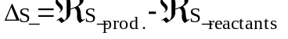
= [(19.6)(2)+(-70.1)(2)]-[58.6+(-27.1)(2)] cal
= -105.4 cal
(b) ΔG° = -nℑE° = -(2)(23060cal/v)(0.30v) = -13800 cal.
(c) ΔG° = ΔH° - TΔS° ; ΔH° = ΔG° + TΔS°
= -13800 + (298)(-105.4) = -45.4 kcal

1973 B
Sn + 2 Ag⁺ → Sn²⁺ + 2 Ag
(a) Calculate the standard voltage of a cell involving the system above.
(b) What is the equilibrium constant for the system above?
(c) Calculate the voltage at 25°C of a cell involving the system above when the concentration of Ag⁺ is 0.0010 molar and that of Sn²⁺ is 0.20 molar.
Answer:
(a) E° = [0.80v - (-0.14v)] = 0.94v
(b) 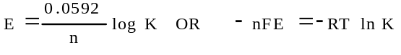
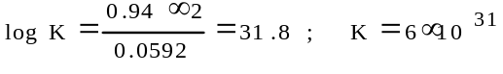
(c) 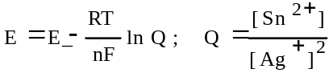
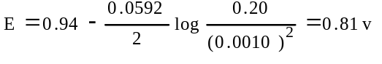

1974 B
A steady current of 1.00 ampere is passed through an electrolytic cell containing a 1 molar solution of AgNO₃ and having a silver anode and a platinum cathode until 1.54 grams of silver is deposited.
(a) How long does the current flow to obtain this deposit?
(b) What weight of chromium would be deposited in a second cell containing 1–molar chromium(III) nitrate and having a chromium anode and a platinum cathode by the same current in the same time as was used in the silver cell?
(c) If both electrodes were platinum in this second cell, what volume of O₂ gas measured at standard temperature and pressure would be released at the anode while the chromium is being deposited at the cathode? The current and the time are the same as in (b)
Answer:
(a)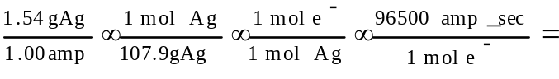
= 1380 sec.
(b) 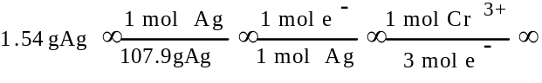
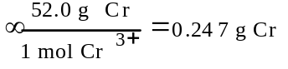
(c) 2 H₂O → O₂ + 4 H⁺ + 4e-
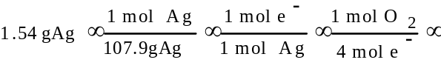
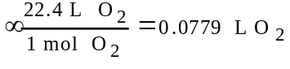

1976 B
(a) Calculate the value of ΔG° for the standard cell reaction
Zn + Cu²⁺(1M) → Zn²⁺(1M) + Cu
(b) One half cell of an electrochemical cell is made by placing a strip of pure zinc in 500 milliliters of 0.10 molar ZnCl₂ solution. The other half cell is made by placing a strip of pure copper in 500 milliliters of 0.010 molar Cu(NO₃)₂ solution. Calculate the initial voltage of this cell when the two half cells are joined by a salt bridge and the two metal strips are joined by a wire.
(c) Calculate the final concentration of copper ion, Cu²⁺, in the cell described in part (b) if the cell were allowed to produce an average current of 1.0 ampere for 3 minutes 13 seconds.
Answer:
(a) E° = 0.76 + 0.34 = 1.10 volts
ΔG° = -nℑE = - (2)(23.06kcal/v)(1.10v) = -50.7 kcal
(b) 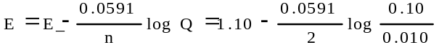
= 1.07 v
(c) (1.0 amp)(193 sec.)(1 farad./96500 coul) =
= 0.0020 faraday
0.0020 faraday/2 = 0.0010 mol Cu²⁺ reduced
(0.0050 - 0.0010) mol = 0.0040 mol Cu²⁺ remaining
0.0040 mol / 0.500 L = 0.0080 M final [Cu²⁺]

1978 B
(a) When 300.0 milliliters of a solution of 0.200 molar AgNO₃ is mixed with 100.0 milliliters of a 0.0500 molar CaCl₂ solution, what is the concentration of silver ion after the reaction has gone to completion?
(b) Write the net cell reaction for a cell formed by placing a silver electrode in the solution remaining from the reaction above and connecting it to a standard hydrogen electrode.
(c) Calculate the voltage of a cell of this type in which the concentration of silver ion is 4×10⁻² M.
(d) Calculate the value of the standard free energy change ΔG° for the following half reaction:
Ag⁺ (1M) + e- → Ag°
Answer:
(a) Ag⁺ + Cl⁻ → AgCl
mol Ag⁺ added = (0.300 L)(0.200 mol/L) =
= 0.0600 mol
mol CaCl₂ added = (0.100 L)(0.0500 mol/L) =
= 0.00500 mol
mol Cl⁻ added = 2(0.00500 mol) = 0.0100 mol
mol Ag⁺ remaining = 0.0600 - 0.0100 = 0.0500 mol
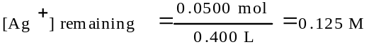
(b) H₂ + 2 Ag⁺ → 2 H⁺ + 2 Ag
(c) 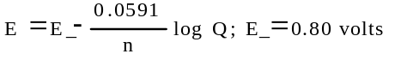
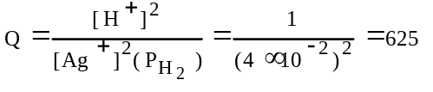
E = (0.80 - 0.08) v = 0.72 volt
(d) ΔG° = -nℑE° = -(1)(96.5kJ/mol)(0.80v) = -77 kJ or -18 kcal

1980 B
M(s) + Cu²⁺(aq) → M²⁺(aq) + Cu(s)
For the reaction above E° = 0.740 volt at 25°C
(a) Determine the standard electrode potential for the reduction half reaction:
M²⁺(aq) + 2e- → M(s)
(b) A cell is constructed in which the reaction above occurs. All substances are initially in their standard states, and equal volumes of the solutions are used. The cell is then discharged. Calculate the value of the cell potential E, when [Cu²⁺] has dropped to 0.20 molar.
(c) Find the ratio [M²⁺]aq/[Cu²⁺]aq when the cell reaction above reaches equilibrium.
Answer:
(a) M(s) → M²⁺(aq) + 2e- X v
Cu²⁺(aq) + 2e- → Cu(s) 0.340 v
---------------------------------------------------------
Cu²⁺(aq) + M(s) → M²⁺(aq) + Cu(s) 0.740 v
X (oxid. potential) = 0.740 v - 0.340 v = 0.400 v
M²⁺(aq) + 2e- → M(s) E° = -0.400 v
(b) M + Cu²⁺ → M²⁺ + Cu
initial: 1.00 M 1.00 M
change: -0.80 M +0.80 M
final: 0.20 M +1.80 M
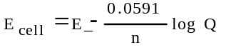
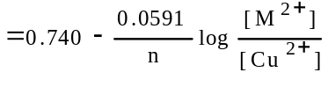
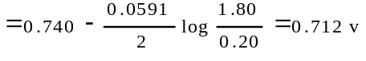
(c) At equilibrium, E_{cell} = 0
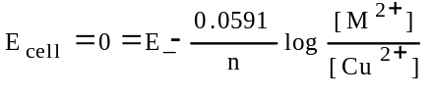
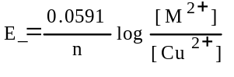
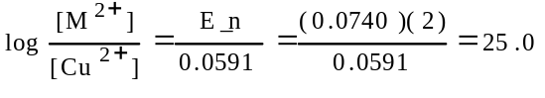
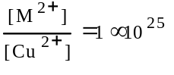

1981 D
A solution of CuSO₄ was electrolyzed using platinum electrodes by passing a current through the solution. As a result, there was a decrease in both [Cu²⁺] and the solution pH; one electrode gained in weight a gas was evolved at the other electrode.
(a) Write the cathode half reaction that is consistent with the observations above.
(b) Write the anode half reaction that is consistent with the observations above.
(c) Sketch an apparatus that can be used for such an experiment and label its necessary components.
(d) List the experimental measurements that would be needed in order to determine from such an experiment the value of the faraday.
Answer:
(a) Cu²⁺ + 2e- → Cu
(b) 2 H₂O → O₂ + 4 H⁺ + 4e-
(c)
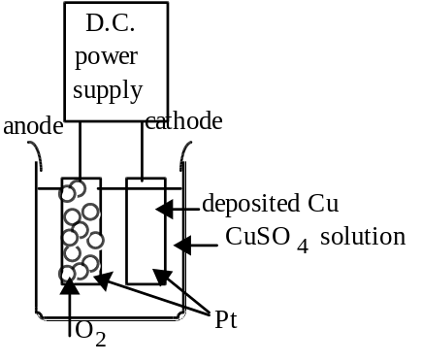
(d) current; time; mass of cathode before and its mass after passage of current - or - volume of O₂ released with its temperature and pressure.

1982 B
When a dilute solution of H₂SO₄ is electrolyzed, O₂(g) is produced at the anode and H₂(g) is produced at the cathode.
(a) Write the balanced equations for the anode, cathode, and overall reactions that occur in this cell.
(b) Compute the coulombs of charge passed through the cell in 100. minutes at 10.0 amperes.
(c) What number of moles of O₂ is produced by the cell when it is operated for 100. minutes at 10.0 amperes?
(d) The standard enthalpy of formation of H₂O(g) is -242 kilojoules per mole. How much heat is liberated by the complete combustion, at 298K and 1.00 atmospheres, of the hydrogen produced by the cell operated as in (c)?
Answer:
(a) cathode: 2 H₂O + 2e- → H₂ + 2 OH⁻
or 2 H⁺ + 2e- → H₂
anode: 2 H₂O → O₂ + 4 H⁺ + 4e-
or 2 O^{2–} → O₂ + 4e-
overall: 2 H₂O → 2 H₂ + O₂
(b) (10.0amp)(10.0 min)(60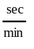) = 6.00×10⁴ coul.
(c) 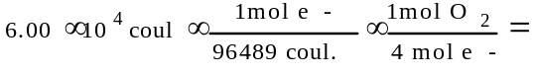
=0.155 mol O₂
(d) from ΔH_{f}° for H₂O:
H₂(g) + ¹/₂ O₂(g) → H₂O(g) ΔH = -242 kJ
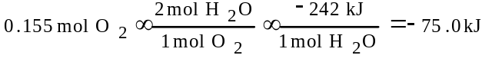
when the H₂ is burned.

1983 C
Ti³⁺ + HOBr → TiO²⁺ + Br⁻ (in acid solution)
(a) Write the correctly balanced half-reactions and net ionic equation for the skeletal equation shown above.
(b) Identify the oxidizing agent and the reducing agent in this reaction.
(c) A galvanic cell is constructed that utilizes the reaction above. The concentration of each species is 0.10 molar. Compare the cell voltage that will be observed with the standard cell potential. Explain your reasoning.
(d) Give one example of a property of this reaction, other than the cell voltage, that can be calculated from the standard cell potential, E°. State the relationship between E° and the property you have specified.
Answer:
(a) Ti³⁺ + H₂O → TiO²⁺ + 2 H⁺ + e-
H⁺ + HOBr + 2e- → Br⁻ + H₂O
2 Ti³⁺ + HOBr + H₂O → 2 TiO²⁺ + 3 H⁺ + Br⁻
(b) HOBr is the oxidizing agent and Ti³⁺ is the reducing agent.
(c) The observed voltage will be greater than the E° value since:
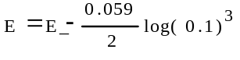
(d) Identification of a property from the group: ΔG, K, pH
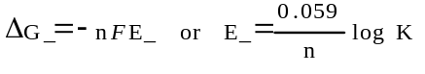
1985 B
(a) Titanium can be reduced in an acid solution from TiO²⁺ to Ti³⁺ with zinc metal. Write a balanced equation for the reaction of TiO²⁺ with zinc in acid solution.
(b) What mass of zinc metal is required for the reduction of a 50.00 millilitre sample of a 0.115 molar solution of TiO²⁺?
(c) Alternatively, the reduction of TiO²⁺ to Ti³⁺ can be carried out electrochemically. What is the minimum time, in seconds, required to reduce another 50.000 millilitre sample of the 0.115 molar TiO²⁺ solution with a direct current of 1.06 amperes?
(d) The standard reduction potential, E°, for TiO²⁺ to Ti³⁺ is +0.060 volt. The standard reduction potential, E°, for Zn²⁺ to Zn_{(s)} is -0.763 volt. Calculate the standard cell potential, E°, and the standard free energy change, ΔG°, for the reaction described in part (a).
Answer:
(a) Zn → Zn²⁺ + 2e-
2 TiO²⁺ + 4 H⁺ + 2e- → 2 Ti³⁺ + 2 H₂O
------------------------------------------------------------------------------
2 TIO²⁺ + 4 H⁺ + Zn → Zn²⁺ + 2Ti³⁺ + 2 H₂O
(b) 0.0500 L × 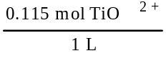 × 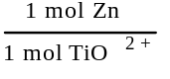 ×
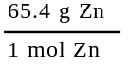 = 0.188 g Zn
(c) 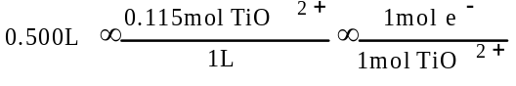
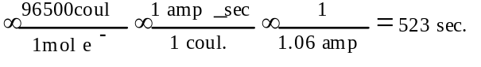
(d) Zn → Zn²⁺ + 2e- E° = 0.763 v
2TiO²⁺ + 4H⁺ + 2e- → 2Ti³⁺ + 2H₂O E° = 0.060 v
E° = 0.823 v
ΔG° = -nℑE°
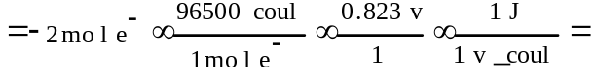
= -1.59×10⁵ J

1986 B
A direct current of 0.125 ampere was passed through 200 millilitres of a 0.25 molar solution of Fe₂(SO₄)₃ between platinum electrodes for a period of 1.100 hours. Oxygen gas was produced at the anode. The only change at the cathode was a slight change in the color of the solution.
At the end of the electrolysis, the electrolyte was acidified with sulfuric acid and was titrated with an aqueous solution of potassium permanganate. The volume of the KMnO₄ solution required to reach the end point was 24.65 millilitres.
(a) How many faradays were passed through the solution?
(b) Write a balanced half-reaction for the process that occurred at the cathode during the electrolysis.
(c) Write a balanced net ionic equation for the reaction that occurred during the titration with potassium permanganate.
(d) Calculate the molarity of the KMnO₄ solution.
Answer:
(a) (1.100 hr)(3600 sec/hr) = 3960 sec.
(3960 sec)(0.125 amp) = 495 coul
495 coul × 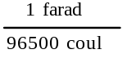 = 5.13×10⁻³ faraday
(b) Fe³⁺ + 1e- → Fe²⁺
(c) MnO₄⁻ + 8 H⁺ + 5e- → Mn²⁺ + 4 H₂O
5 Fe²⁺ → 5 Fe³⁺ + 5e-
---------------------------------------------------------------------------------
MnO₄⁻ + 8 H⁺ + 5 Fe²⁺ → 5 Fe³⁺ + Mn²⁺ + 4 H₂O
(d) 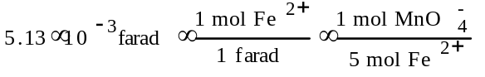
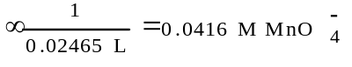

1987 D
A dilute solution of sodium sulfate, Na₂SO₄, was electrolyzed using inert platinum electrodes. In a separate experiment, a concentrated solution of sodium chloride, NaCl, was electrolyzed also using inert platinum electrodes. In each experiment, gas formation was observed at both electrodes.
(a) Explain why metallic sodium is not formed in either experiment.
(b) Write balanced equations for the half–reactions that occur at the electrodes during electrolysis of the dilute sodium sulfate solution. Clearly indicate which half–reaction occurs at each electrode.
(c) Write balanced equations for the half–reactions that occur at the electrodes during electrolysis of the concentrated sodium chloride solution. Clearly indicate which half–reaction occurs at each electrode.
(d) Select two of the gases obtained in these experiments, and for each gas, indicate one experimental procedure that can be used to identify it.
Answer:
(a) Na⁺ is not reduced as easily as H₂O (or H⁺ or OH–). OR
If Na(s) were formed, it would rapidly react with water to reform Na⁺.
(b) Anode: 2 H₂O → O₂ + 4 H⁺ + 4e-
cathode: 2 H₂O + 2e- → H₂ + 2 OH⁻
or: 2 H⁺ + 2e- → H₂
(c) anode: 2 Cl⁻ → Cl₂ + 2e-
cathode: 2 H₂O + 2e- → H₂ + 2 OH⁻
or: 2 H⁺ + 2e- → H₂
(d) H₂ - “pop” with a lit splint; O₂ - ignites a glowing splint; Cl₂ - yellowish-green color
(other suitable tests accepted)

1988 B
An electrochemical cell consists of a tin electrode in an acidic solution of 1.00 molar Sn²⁺ connected by a salt bridge to a second compartment with a silver electrode in an acidic solution of 1.00 molar Ag⁺.
(a) Write the equation for the half–cell reaction occurring at each electrode. Indicate which half–reaction occurs at the anode.
(b) Write the balanced chemical equation for the overall spontaneous cell reaction that occurs when the circuit is complete. Calculate the standard voltage, E°, for this cell reaction.
(c) Calculate the equilibrium constant for this cell reaction at 298K.
(d) A cell similar to the one described above is constructed with solutions that have initial concentrations of 1.00 molar Sn²⁺ and 0.0200 molar Ag⁺. Calculate the initial voltage, E°, of this cell.
Answer:
(a) Sn → Sn²⁺ + 2e- anode reaction
Ag⁺ + e- → Ag
(b) 2 Ag⁺ + Sn → 2 Ag + Sn²⁺
E° = [0.80v - (-0.14v)] = 0.94v
(c)
(d)
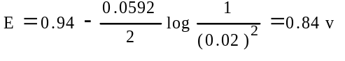

1989 B
The electrolysis of an aqueous solution of potassium iodide, KI, results in the formation of hydrogen gas at the cathode and iodine at the anode. A sample of 80.0 millilitres of a 0.150 molar solution of KI was electrolyzed for 3.00 minutes, using a constant current. At the end of this time, the I₂ produced was titrated against a 0.225 molar solution of sodium thiosulfate, which reacts with iodine according to the equation below. The end point of the titration was reached when 37.3 millilitres of the Na₂S₂O₃ solution had been added.
I₂ + 2 S₂O₃²⁻ → 2 I⁻ + S₄O₆²⁻
(a) How many moles of I₂ was produced during the electrolysis?
(b) The hydrogen gas produced at the cathode during the electrolysis was collected over water at 25°C at a total pressure of 752 millimetres of mercury. Determine the volume of hydrogen collected. (The vapor pressure of water at 25°C is 24 millimetres of mercury.)
(c) Write the equation for the half–reaction that occurs at the anode during the electrolysis.
(d) Calculate the current used during the electrolysis.
Answer:
(a) 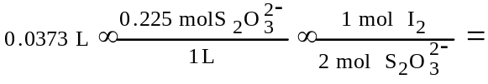
= 4.20×10⁻³ mol I₂
(b) P_{H2} = P_{total} - P_{H2O}
= (752 - 24) mm Hg = 728 mm Hg
1 mol H₂ = 1 mol I₂
PV = nRT ; V = nRT/P
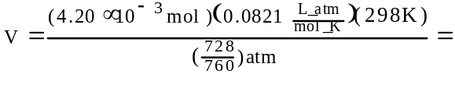
= 0.107 L
(c) At anode: 2 I– → I₂ + 2e-
(d) 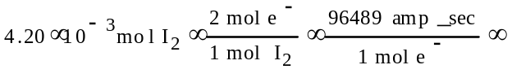
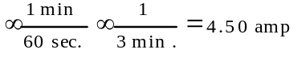

1991 D
Explain each of the following.
(a) When an aqueous solution of NaCl is electrolyzed, Cl₂(g) is produced at the anode, but no Na(s) is produced at the cathode.
(b) The mass of Fe(s) produced when 1 faraday is used to reduce a solution of FeSO₄ is 1.5 times the mass of Fe(s) produced when 1 faraday is used to reduce a solution of FeCl₃.
(c) Zn + Pb²⁺ (1–molar) → Zn²⁺ (1–molar) + Pb
The cell that utilizes the reaction above has a higher potential when [Zn²⁺] is decreased and [Pb²⁺] is held constant, but a lower potential when [Pb²⁺] is decreased and [Zn²⁺] is held constant.
- The cell that utilizes the reaction given in (c) has the same cell potential as another cell in which [Zn²⁺] and [Pb²⁺] are each 0.1–molar.
Answer:
(a) Cl– is more easily oxidized than water
water is more easily reduced than Na⁺
(b) Fe²⁺ req. 2 ^{farad}/_{mol} Fe(s) or 1 farad → ¹/₂ mol Fe(s)
Fe³⁺ req. 3 ^{farad}/_{mol} Fe(s) or 1 farad → ¹/₃ mol Fe(s)
for equal numbers of farad 1/2:1/3 :: 1.5:1
(c) using LeChatelier’s principle
if [Zn²⁺] ↓, reaction shifts →, ∴ cell potential
if [Pb²⁺] ↓, reaction shifts ←, ∴ cell potential ↓
or using the Nernst Equation
E_{cell} = E° - RT lnQ, where Q = [Zn²⁺]/[Pb²⁺],
if [Zn²⁺] ↓, Q<1, E_{cell} > E°
if [Pb²⁺] ↓, Q>1, E_{cell} < E°
(d) [Zn²⁺]/[Pb²⁺] does not change regardless of the values, ∴ E_{cell} = E°
or [Zn²⁺]/[Pb²⁺] = 1; ln Q = 0; E_{cell} = E°

1992 B
An unknown metal M forms a soluble compound, M(NO₃)₂.
(a) A solution of M(NO₃)₂ is electrolyzed. When a constant current of 2.50 amperes is applied for 35.0 minutes, 3.06 grams of the metal M is deposited. Calculate the molar mass of M and identify the metal.
(b) The metal identified in (a) is used with zinc to construct a galvanic cell, as shown below. Write the net ionic equation for the cell reaction and calculate the cell potential, E°.
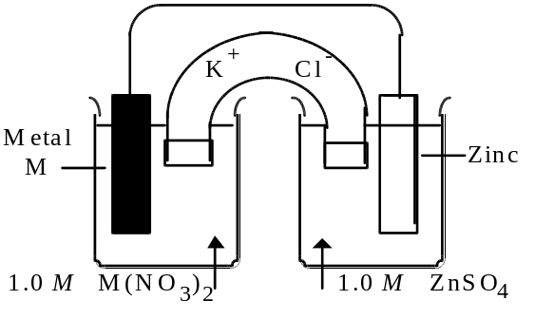
(c) Calculate the value of the standard free energy change, ΔG°, at 25°C for the reaction in (b).
(d) Calculate the potential, E, for the cell shown in (b) if the initial concentration of ZnSO₄ is 0.10-molar, but the concentration of the M(NO₃)₂ solution remains unchanged.
Answer:
(a) 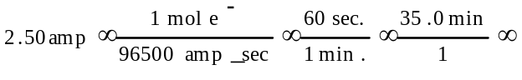
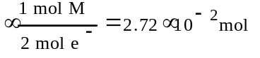
3.06 g/2.72×10⁻² mol = 112 g/mol; ∴ metal is Cd
(b) Zn → Zn²⁺ + 2e- E° = +0.76 v
Cd²⁺ + 2e- → Cd E° = –0.40 v
------------------------------------------
Cd²⁺ + Zn → Cd + Zn²⁺ E° = +0.36 v
(c) ΔG° = -nℑE° = -(2)(96.5 kJ/v)(0.36v) = -69 kJ
(d) 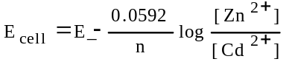
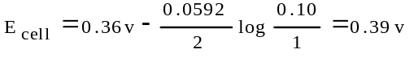

1993 D
A galvanic cell is constructed using a chromium electrode in a 1.00-molar solution of Cr(NO₃)₃ and a copper electrode in a 1.00-molar solution of Cu(NO₃)₂. Both solutions are at 25°C.
(a) Write a balanced net ionic equation for the spontaneous reaction that occurs as the cell operates. Identify the oxidizing agent and the reducing agent.
(b) A partial diagram of the cell is shown below.
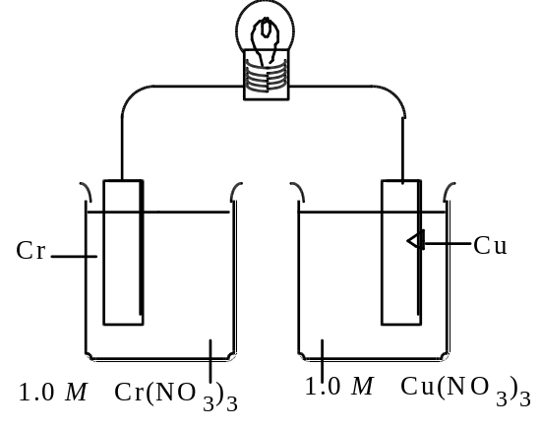
(i) Which metal is the cathode?
(ii) What additional component is necessary to make the cell operate?
(iii) What function does the component in (ii) serve?
(c) How does the potential of this cell change if the concentration of Cr(NO₃)₃ is changed to 3.00-molar at 25°C? Explain.
Answer:
(a) 2 Cr + 3 Cu²⁺ → 2 Cr³⁺ + 3 Cu
Cr = reducing agent; Cu²⁺ = oxidizing agent
(b) (i) Cu is cathode
(ii) salt bridge
(iii) transfer of ions or charge but not electrons
(c) E_{cell} decreases.
use the Nernst equation to explain answer

1996 D
Sr(s) + Mg²⁺ → Sr²⁺ + Mg(s)
Consider the reaction represented above that occurs at 25°C. All reactants and products are in their standard states. The value of the equilibrium constant, K_{eq}, for the reaction is 4.2×10¹⁷ at 25°C.
(a) Predict the sign of the standard cell potential, E°, for a cell based on the reaction. Explain your prediction.
(b) Identify the oxidizing agent for the spontaneous reaction.
(c) If the reaction were carried out at 60°C instead of 25°C, how would the cell potential change? Justify your answer.
(d) How would the cell potential change if the reaction were carried out at 25°C with a 1.0-molar solution of Mg(NO₃)₂ and a 0.10-molar solution of Sr(NO₃)₂ ? Explain.
(e) When the cell reaction in (d) reaches equilibrium, what is the cell potential?
Answer:
(a) (+); K > 1 OR reaction is spontaneous OR E° for Sr²⁺ is more positive OR E° for Sr is more negative OR E° = +0.52 v
(b) Mg²⁺
(c) increase; E° = 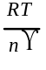 ln Q, when Q = 1 then as T increases so does E°.
(d) increase; E_{cell} = E° – 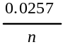 ln Q, when Q = 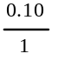 then E_{cell} becomes larger.
OR an explanation using LeChâtelier’s Principle.
(e) E_{cell} = 0

1997 B
In an electrolytic cell, a current of 0.250 ampere is passed through a solution of a chloride of iron, producing Fe(s) and Cl₂(g).
(a) Write the equation for the half-reaction that occurs at the anode.
(b) When the cell operates for 2.00 hours, 0.521 gram of iron is deposited at one electrode. Determine the formula of the chloride of iron in the original solution.
(c) Write the balanced equation for the overall reaction that occurs in the cell.
(d) How many liters of Cl₂(g), measured at 25°C and 750 mm Hg, are produced when the cell operates as described in part (b) ?
(e) Calculate the current that would produce chlorine gas from the solution at a rate of 3.00 grams per hour.
Answer:
(a) 2 Cl– – 2 e⁻ → Cl₂
(b) 0.250 amp × 7200 sec = 1800 coulomb
1800 coul × 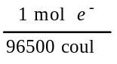 = 0.0187 mol e⁻
0.521 g Fe × 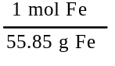 = 0.00933 mol Fe
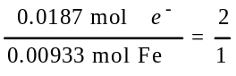
Fe²⁺ + 2e⁻ → Fe ; ∴ FeCl₂
(c) Fe²⁺ + 2 Cl– → Fe + Cl₂
(d) 0.0187 mol e⁻ × 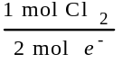 = 0.00933 mol Cl₂
V = 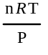 = 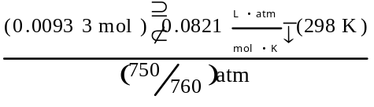
= 0.231 L
(e) 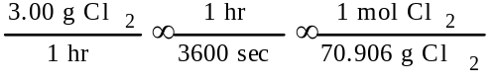
× 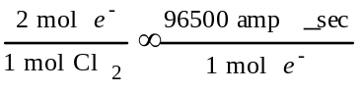 = 2.27 amp
OR
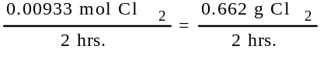 = 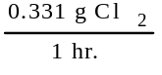
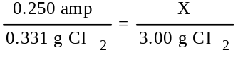 ; X = 2.27 amp

1998 D
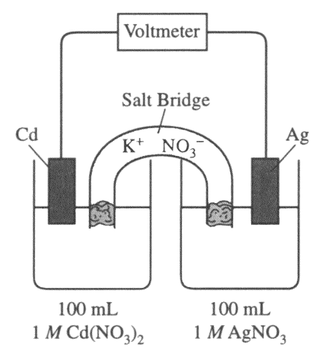
Answer the following questions regarding the electrochemical cell shown.
(a) Write the balanced net-ionic equation for the spontaneous reaction that occurs as the cell operates, and determine the cell voltage.
(b) In which direction do anions flow in the salt bridge as the cell operates? Justify your answer.
(c) If 10.0 mL of 3.0-molar AgNO₃ solution is added to the half-cell on the right, what will happen to the cell voltage? Explain.
(d) If 1.0 gram of solid NaCl is added to each half-cell, what will happen to the cell voltage? Explain.
(e) If 20.0 mL of distilled water is added to both half-cells, the cell voltage decreases. Explain.
Answer
(a) 2 Ag⁺ + 2 e⁻ → 2 Ag E° = +0.80 v
Cd – 2 e-⁻ → Cd²⁺ E° = +0.40 v
2 Ag⁺ + Cd → 2 Ag + Cd²⁺ E = +1.20v
(b) Anions flow into the cadmium half-cell. As the cell operates, Cd²⁺ cations increase in number and need to be balanced by an equal number of anion charges from the salt bridge.
(c) Cell voltage will increase. An increase in silver ion concentration will result in faster forward reaction and a higher cell potential.
(d) Cell voltage will decrease. As the salt dissolves, the Cl– ion will cause the Ag⁺ ion to precipitate as AgCl and decrease the [Ag⁺]. This will result in a slower forward reaction and a decrease in cell potential. Since cadmium chloride is a soluble salt, it will not affect the cadmium half-cell.
(e) E_{cell} = 1.20v – 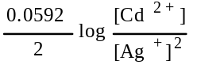 ; while both concentrations are 1.0M, the cell potential is 1.20v. But if each solution’s concentration is cut in half, then, E_{cell} = 1.20v – 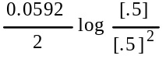 = 1.19v

